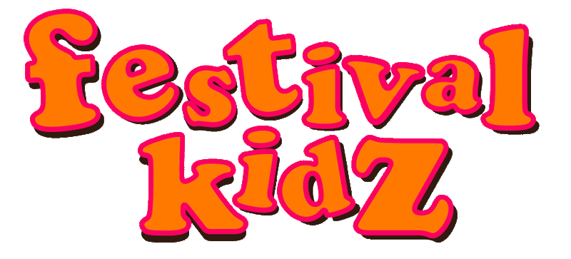Packing List
Sleeping | Found  (tick) | Packed  (tick)
Tent
Tent poles
Tent pegs
Mallet
Fairy lights/bunting/flags for tent
Sleeping mats , mattresses or camp beds
Sleeping bags
Pillows
Ear plugs (adults)/ Ear defenders (children)
Torches/spare batteries
Lantern
Travel dustpan and brush
Gaffer tape/cable ties/string/penknife
Transport | Found  (tick) | Packed  (tick)
Festival Wagon/cushions/blankets
Solar powered fairy lights/decorations
Cooking | Found  (tick) | Packed  (tick)
Stove/gas bottle
Pans
Bowls/plates
Cutlery
Cups
Cafetiere (or travel coffee press)
Table and chairs
Water container/bottle
Washing up bowl/liquid/sponge
Picnic Blanket
Black bin liners
Tea towels
Kitchen towel
Sharp knife
Spatula, serving spoon, tongs
Food | Found  (tick) | Packed  (tick)
Cool box
butter/eggs/bacon/milk
Breakfasts – cereal/pancake mix
Meal one: Bread/chicken/cucumber
Meal two: Rice and chicken in white sauce/sweetcorn
Meal three: Pasta and sauce/broccoli
Meal four: sausages and mash with beans
Noodles in a pot
Nuts/cereal bars/fruit
Crisps/biscuits/cake
Coffee/tea/sugar
Salt/pepper
Brown Sauce/Chilli Sauce/Ketchup
Clothes | Found  (tick) | Packed  (tick)
Onesies/pyjamas
Dresses
Tops
Leggings/shorts/trousers
Jumpers/thermals
Socks/Thick socks
Underwear
Wellies
Waterproofs
Trainers/Walking boots
Sandals
Large bag for wet clothes at edge of tent
Sun hats/woolly hats
Washing | Found  (tick) | Packed  (tick)
Towels
Soap/shampoo
Sun cream
Hairbrush
Wet wipes
Toothbrushes/toothpaste
Toilet | Found  (tick) | Packed  (tick)
Bucket with lid/portable toilet/Boginabag
Potty/ Travel Potty
Antibaterial Hand gel
Toilet roll
Compost bags
Spray cleaner
Medicines | Found  (tick) | Packed  (tick)
First aid kit
Calpol
Plasters
Savlon/calamine cream
Ibuprofen, paracetomol, piriton, etc
Insect Repellent
Rehydration sachets
Play | Found  (tick) | Packed  (tick)
Ball/poi/Hula Hoops/Kite
Dressing up clothes
Face paint/glitter/temporary tattoos
Glowsticks/bubbles
Colouring in/Pens/Puzzles
Children’s special toys/comforters
Add your own items here

